VPC TRANSIT GATEWAY FOR 3 VPC’S

Vpc transit gateway will help us to connect blw multiple vpc on cloud
It will create a hub and spoke design to connect multiple vpc

Vpc transit gateway is chargable
I will be creating a transit gateway for 3 vpc
And I need to create attachments for every vpc
I will be giving 1 public subnet and 2 private subnets with vpc diff for every subnet

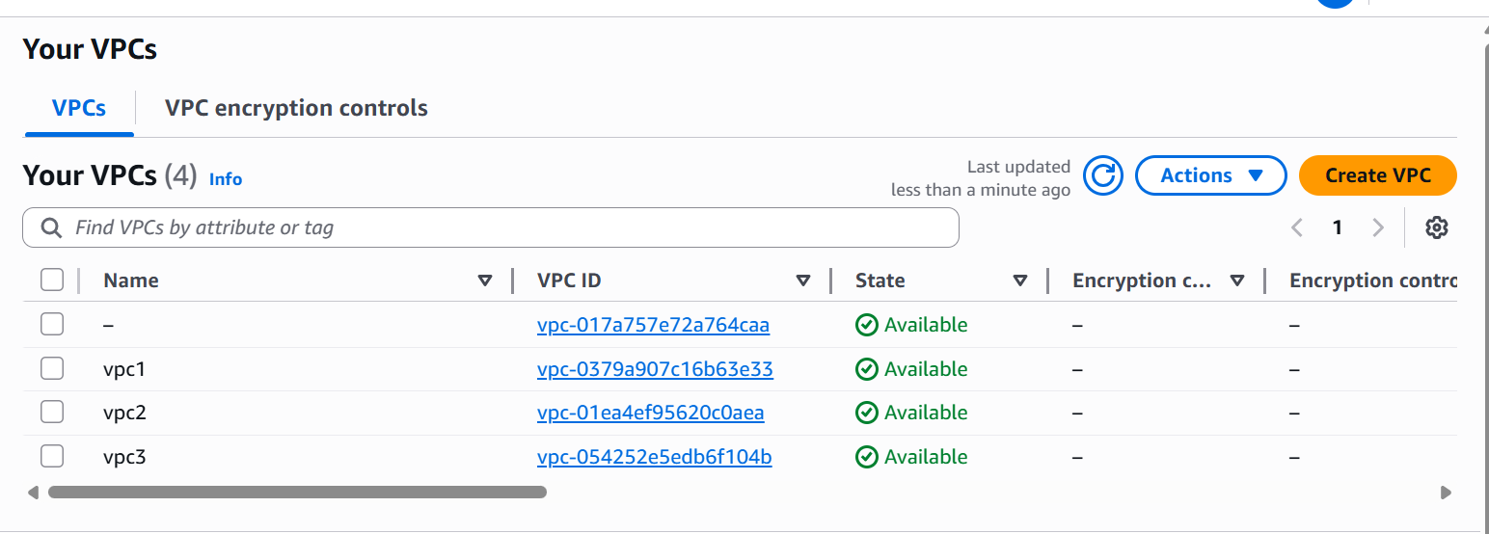

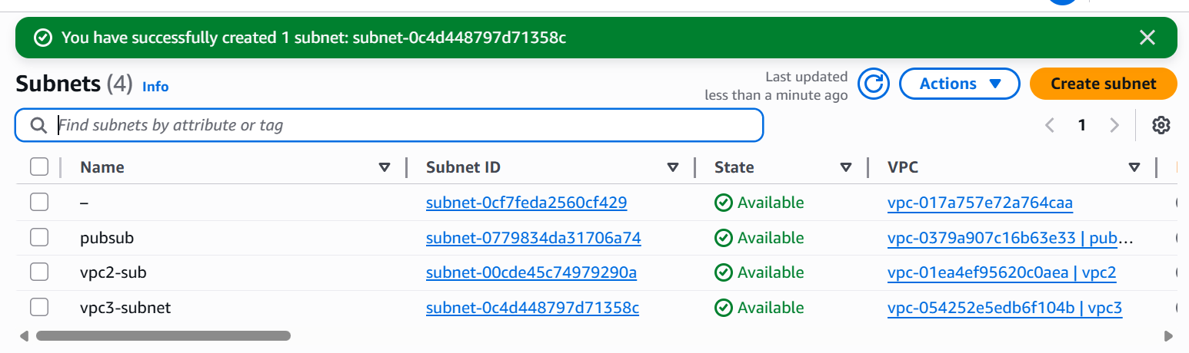

1 subnet for every 1 vpc

Now I will be creating a transit gateway
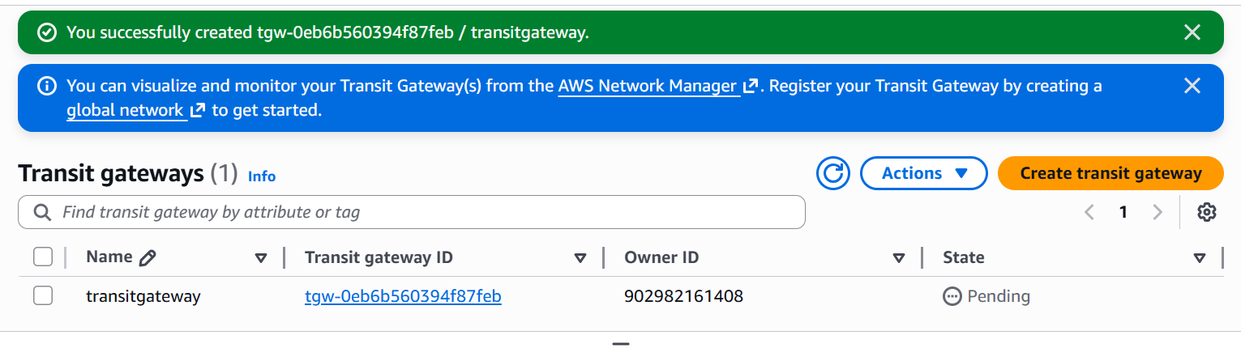

Next create tansit gateway attachments for every vpc
I am creating 3 attachements for 3 vpc
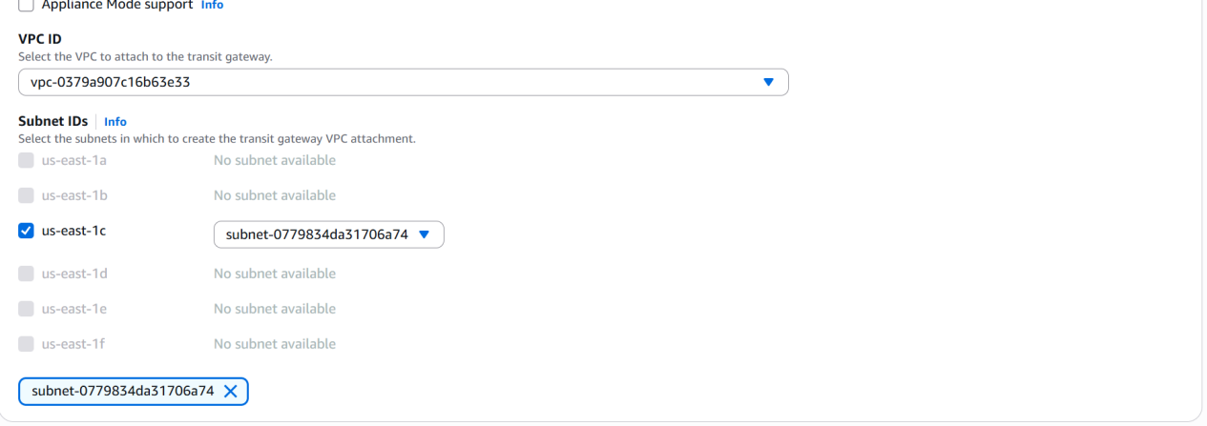

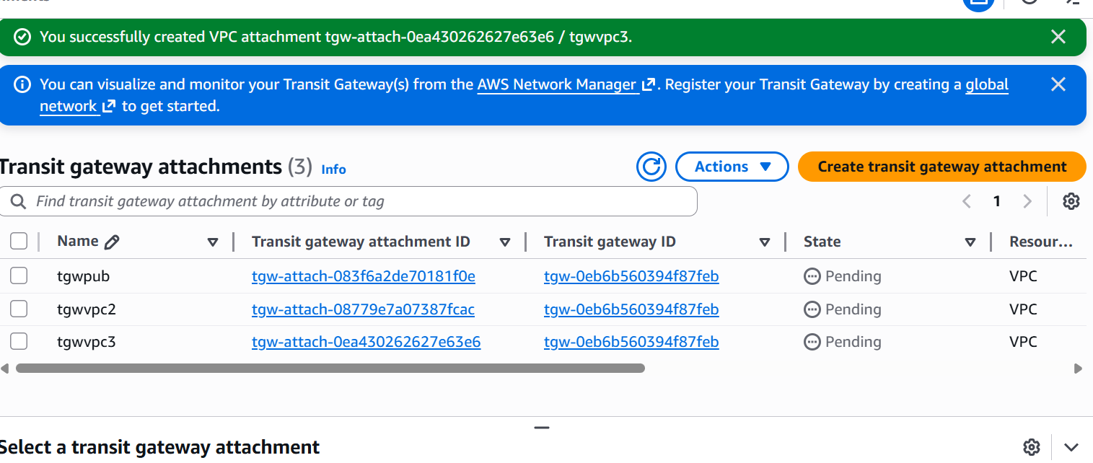

Now it will automatically creates a route table for transit gateway
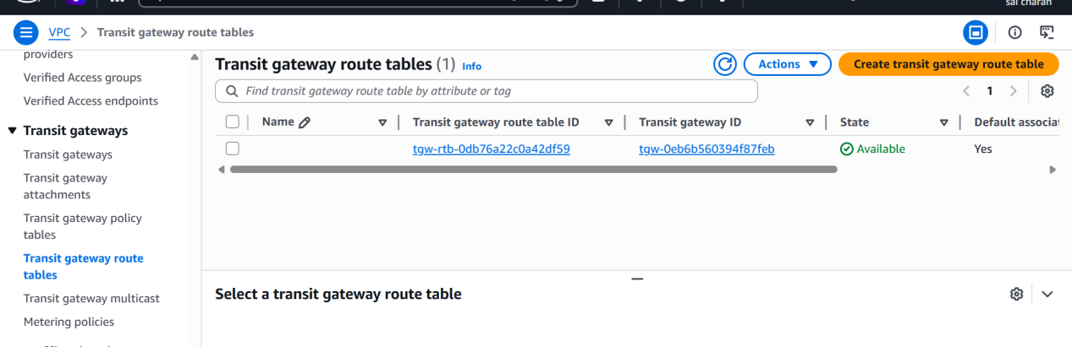

Now head back to vpc route table
And allow other vpc ips in route table for every vpc route
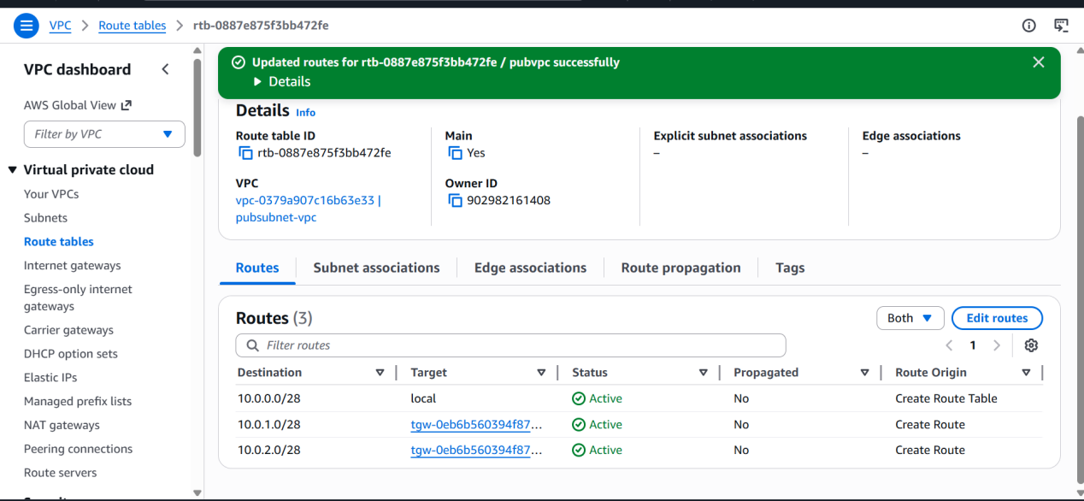

Do this for every vpc we want to connect to transit gateway

I will be creating a new instance for every 1 vpc
Total 3 instances and 1 is public and 2 private with different vpc for every instance
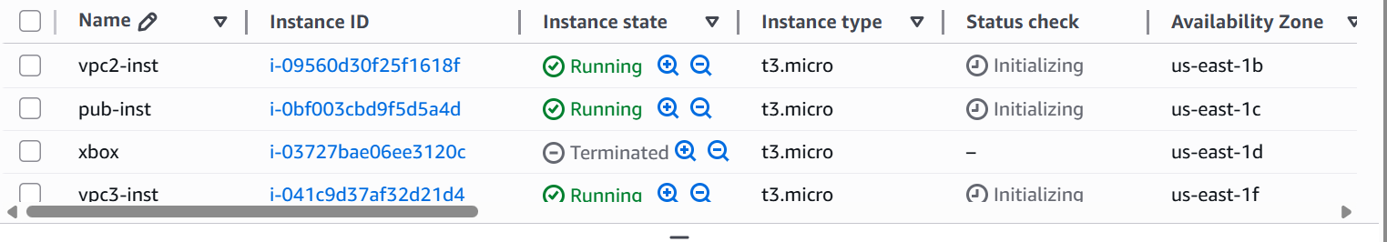

Now the transit gateway was successful blt 3 vpcs and can ping with private ip of private subnets

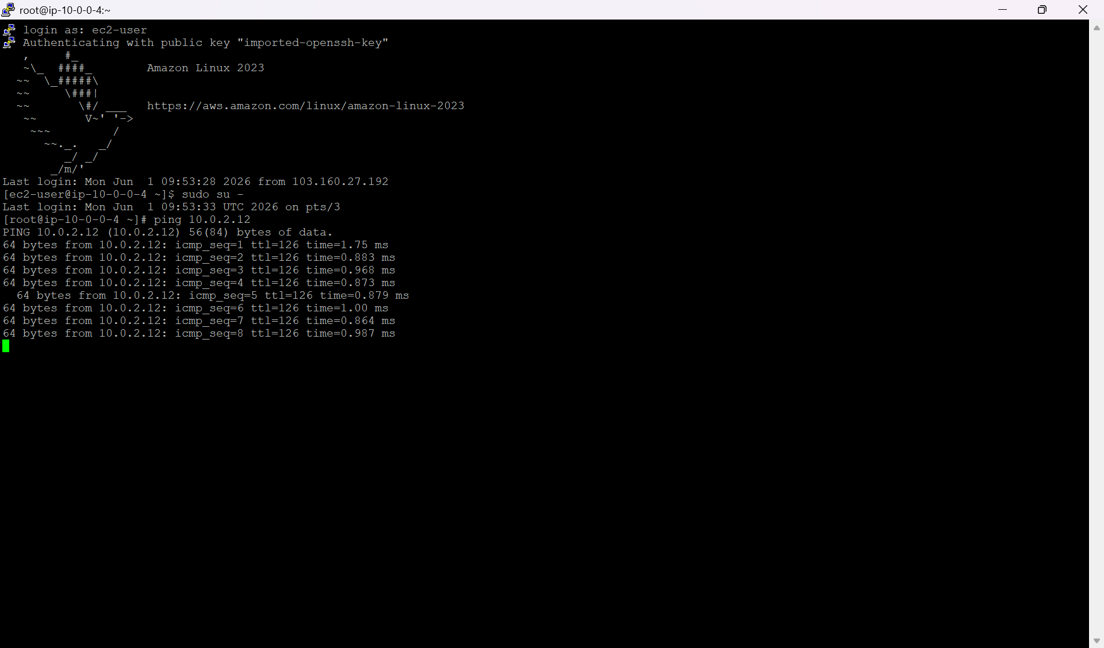

Configure VPC endpoints to securely access AWS services without internet gateways or NAT gateways, ensuring data privacy and minimizing exposure to external threats

I will be configuring vpc endpoints to access aws service I.e, s3
For my private server
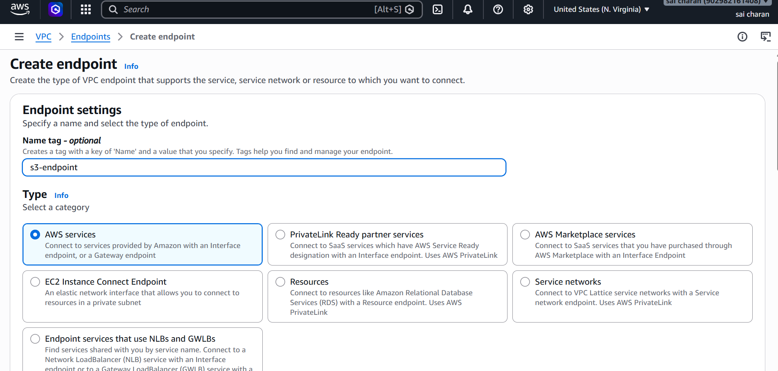

Add priv subnet in route tabel while creating endpoint

I have created new 2 subnets under 1 vpc
1 priv subnet and 1 public subnet

Then connect to public instance
Use aws configure the add accesskey and secret key in cli
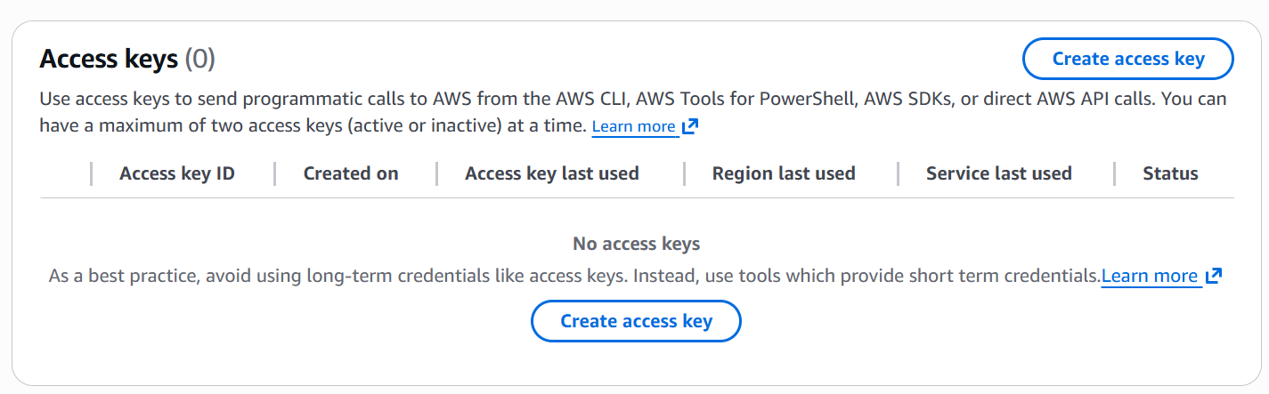

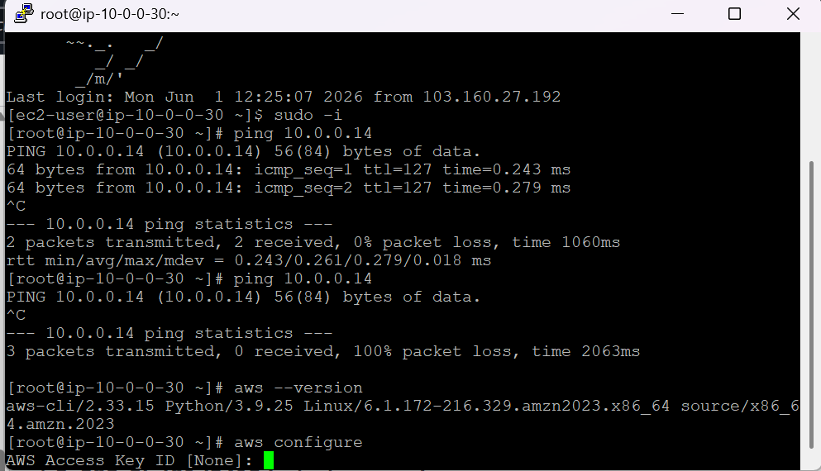

I have added secretkey and accesskey to aws cli

Now I am using my public server as jump server for my private server

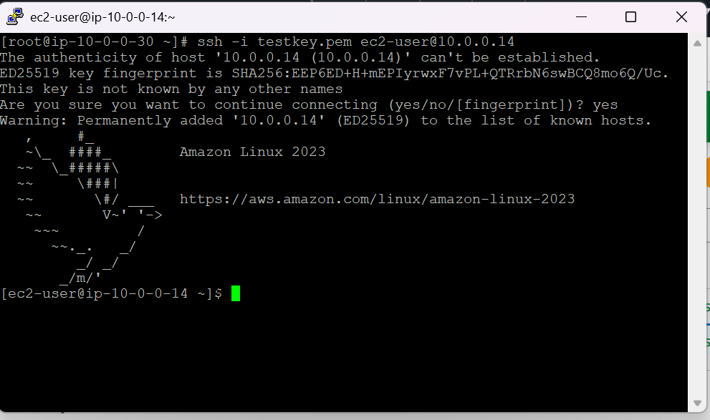

As we can see I have connected to private server through my public instance as jump server

Now we need to see if it can call for s3 through endpoint from private server

